Incheon Free Economic Zone Authority to Present Incheon’s AI City Vision at CES 2026 under the Theme ‘Destination Incheon’

- From Smart City to AI City: Presenting the Next Evolution of Urban Life at the INCHEON–IFEZ Booth
- 51 Companies to Participate — Supporting the Global Expansion of Incheon’s Innovative Businesses

INCHEON, South Korea--The Incheon Free Economic Zone (IFEZ) Authority will take part in CES, the world's largest information technology exhibition, for the third consecutive year to present Incheon’s AI City vision on the global stage.

The IFEZ Authority announced that it will operate the “Incheon–IFEZ Booth” at CES 2026, to be held in Las Vegas from January 6 to 9, 2026, under the theme “Destination Incheon—From Smart City to AI City: The Next Evolution of Urban Life.”

CES is held every January in Las Vegas and is widely recognized as a platform for innovation where the latest technology trends and global businesses come together. The IFEZ Authority will set up its booth the AI Zone of the North Hall at the Las Vegas Convention Center.

The CES 2026 Incheon–IFEZ Booth will consist of three zones: the AI Smart Living Zone, featuring technologies that enhance services for city residents, including mobility, safety, energy, and healthcare; the AI Innovation Hub Zone, showcasing AI solutions that transform industrial sectors including manufacturing, logistics, food, and pharmaceuticals; and the AI Creative City Zone, highlighting AI-driven content and experiential innovations.

On January 6, the Incheon–IFEZ Booth will officially open with an inauguration ceremony. This will be followed by a series of programs on the main stage, including the Global AI City Session, which brings together global urban and industry experts to discuss practical pathways for collaboration in support of Incheon’s transition from a smart city to an AI city.

On the second day, CES 2026 Incheon Night will be held, providing a networking platform where participating Incheon-based companies and overseas firms get together to explore practical cooperation. The event will bring together investors, buyers, and global partners for partnership discussions, along with a series of demo showcases.

On January 8, a dedicated Business Day will be organized for 15 participating companies as part of a visiting delegation, supporting their global expansion through one-on-one matchmaking and on-site meetings with buyers, venture capital firms, and accelerators.

IFEZ will present technologies from 10 innovative local companies and support the participation of a total of 51 companies at CES, including 10 in the Eureka Park, 6 in the Global Pavilion, 15 companies of the Incheon Startup Park delegation, and 10 taking part in the Innovation Awards Showcase. In particular, IFEZ will intensify its support by moving beyond exhibition participation to connect companies with investors and global partners through meetings, product demonstrations, and on-site networking—driving tangible results for global market expansion.

The IFEZ Authority has systematically prepared startups for substantive participation in CES by operating a comprehensive set of programs, including pre-event business matchmaking, global media meetups, training for global exhibition participation, and support for CES Innovation Awards applications. As a result, 14 companies secured a total of 17 CES Innovation Awards, the highest number ever achieved. Building on this record-breaking performance, IFEZ plans to expand support this year by operating a dedicated CES Innovation Awards Showcase for award-winning companies, further enhancing their global visibility and accelerating follow-up business opportunities.

Mayor Yoo Jeong-bok of Incheon stated, “CES 2026 represents a critical opportunity to elevate the global capabilities of both Incheon and its companies to the next level.” He added, “Under the theme ‘Destination Incheon,’ we will share IFEZ’s AI City strategy with the world and make every effort to establish Incheon not merely as a city people pass through, but as a destination the world moves toward—and as a leading global innovation city in the age of AI.”

Detailed information on participating companies and programs can be found on the official CES 2026 INCHEON–IFEZ website (https://www.ces-ifez.com/).

Contacts
IFEZ (Incheon Free Economic Zone)
Assistant Officer
Soyeon Back
syback@korea.kr
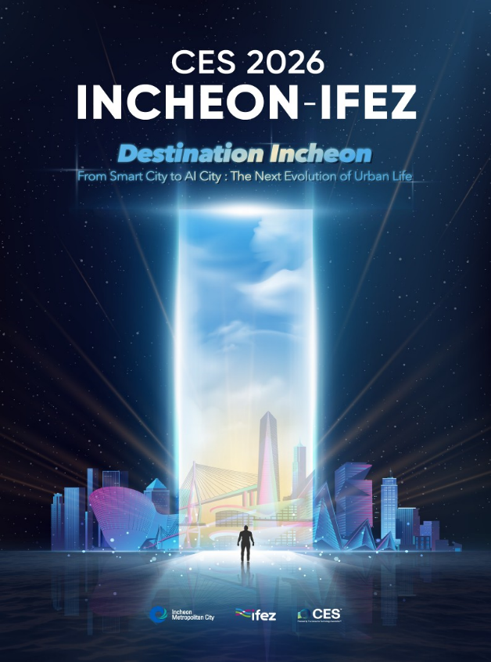
Poster for CES 2026 INCHEON-IFEZ (Image: IFEZ)

